MSME COPILOT AI
AI-Powered Business Operating Assistant for MSMEs

HACKMATRIX 2026
ROUND 2
TEAM
TECH GIRLS
PROJECT
MSME Copilot AI

PROJECT DOCUMENTATION
A unified AI-powered workspace for everyday MSME operations.
Prepared for HackMatrix 2026 – Round 2

1. Team Information
Event | HackMatrix 2026 – Round 2
Team Name | TECH GIRLS
Team Leader | Vinita Patidar
Contact | Vinitaforever20@gmail.com/8109182931
Team Members | Suryanshi Mourya, Khushi Singh
2. Problem Statement
Small and medium-sized businesses often struggle to manage day-to-day operations, access government support, generate business documents, and identify cybersecurity risks. Existing solutions are frequently fragmented across different platforms, making them difficult for small businesses to use efficiently.
MSME Copilot AI addresses this by bringing essential business assistance capabilities together in a single AI-powered platform.
3. Project Title
MSME Copilot AI
AI-Powered Business Operating Assistant for MSMEs
4. Project Summary
MSME Copilot AI is an AI-powered business assistance platform designed to help Micro, Small and Medium Enterprises manage common business tasks through a unified digital workspace.
• AI business assistance
• Government scheme discovery
• Document management
• Invoice generation
• Security scanning
• Business dashboard
• User settings and preferences
5. Problem Being Solved
• Limited access to centralized digital business tools
• Difficulty discovering relevant government schemes
• Manual document management
• Time-consuming invoice preparation

• Exposure to suspicious URLs and scam messages
• Lack of accessible cybersecurity assistance
• Multiple disconnected tools for different business activities
6. USP — Unique Selling Point
"One AI-powered workspace for everyday MSME operations."
Unlike solutions focused on only one business function, MSME Copilot AI combines business assistance, government support, document management, invoicing and cybersecurity into a single platform.
Its key differentiator is the integrated MSME-focused workflow, allowing users to move between different business tasks without switching between multiple applications.
7. Key Features
Feature | Description
AI Business Assistant | Provides an interactive AI interface for business-related assistance.
Government Schemes | Users can search programs and view scheme name, category, description, benefits, eligibility, next steps and official portal.
Document Management | Users can upload, view and manage business documents from the platform.
Invoice Generator | Generates business invoices through a structured interface.
Security Scanner | Scans URLs, emails and suspicious messages, providing risk level, confidence score, recommendation and detected indicators.
Business Dashboard | Provides a centralized overview of the platform's business assistance modules.
Settings | Allows users to manage profile information and preferences such as notifications, security alerts, dark mode and language.

8. Platform Preview
The final documentation should include screenshots of the major user-facing modules. Place the Dashboard first, followed by the major functional modules.
• 1. Login Page
• 2. Dashboard
• 3. AI Assistant
• 4. Documents
• 5. Government Schemes
• 6. Invoice Generator
• 7. Security Scanner
• 8. Settings
S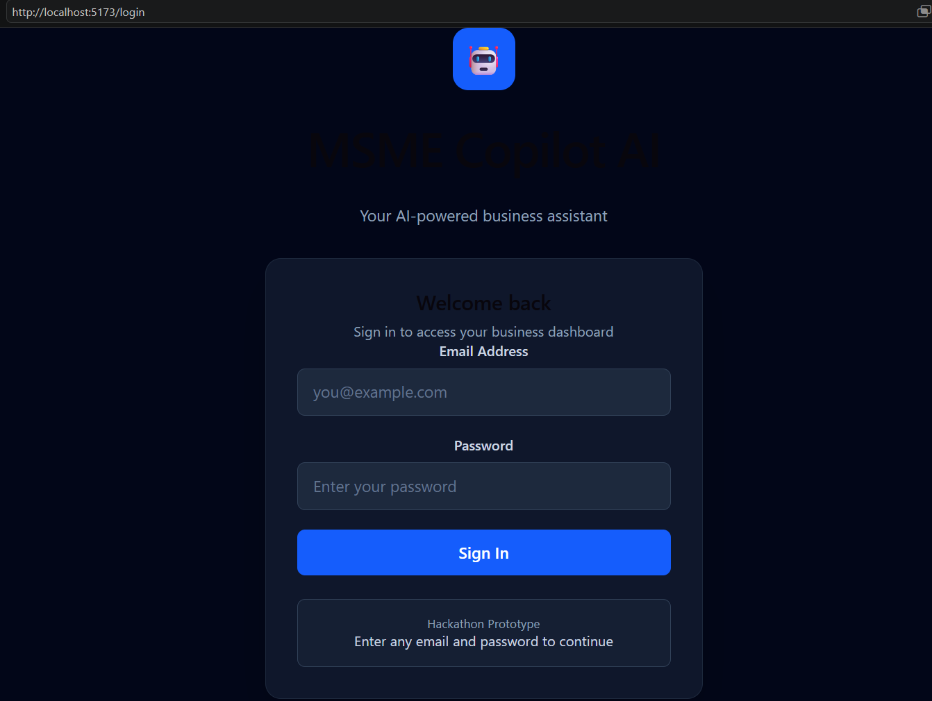
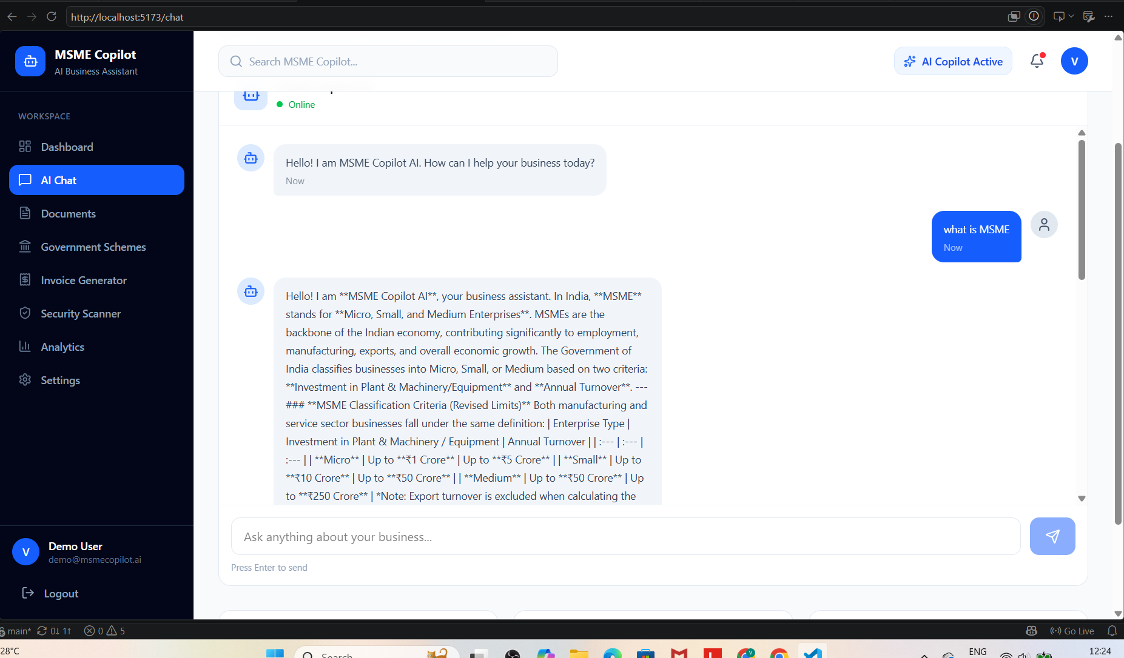

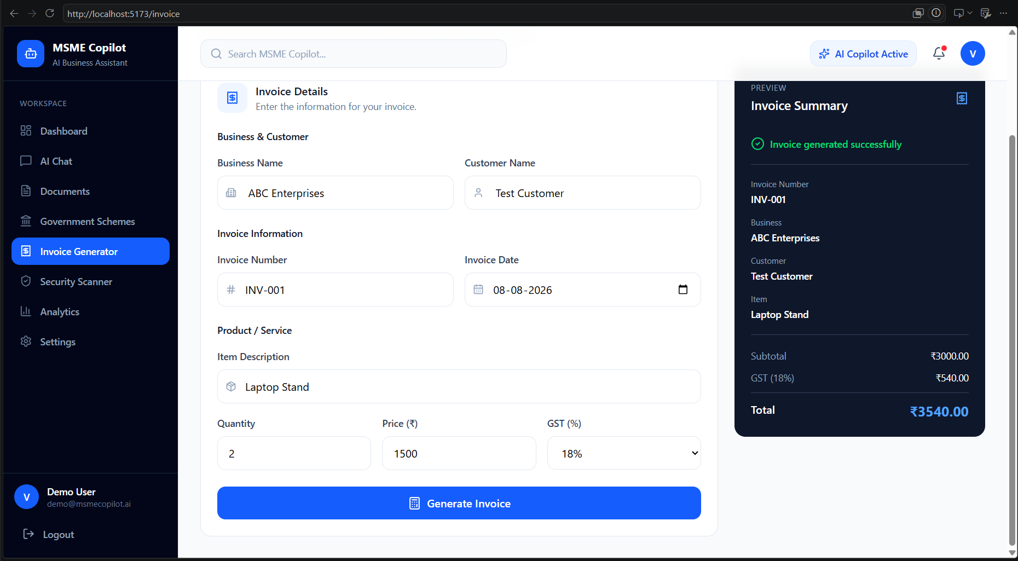

9. Technology Stack
Frontend | React.js
Build Tool | Vite
Styling | Tailwind CSS
Icons | Lucide React
Backend | FastAPI
Programming Language | Python
Database | SQLite / SQLAlchemy
AI | Generative AI API
API Communication | REST APIs / Fetch
Development | VS Code
Version Control | Git + GitHub
10. Project Links
GitHub Repository
https://github.com/Patidarvinita08/MSME-Copilot-Hackathon
Demo Video
Add your final demo video link here
https://drive.google.com/file/d/1rvkH2Z6X9DBnNCs0gXSQmz_DOPxMfQX9/view?usp=drive_link
11. Future Scope
• Advanced RAG-based business knowledge assistant
• Personalized government scheme recommendations
• Automated financial insights
• GST and accounting integrations
• Automated document intelligence
• Advanced fraud and phishing detection
• Multi-agent business workflows
• Cloud deployment and scalable infrastructure
• Mobile application
• Multilingual support for Indian MSMEs

